Part 1.

1. Add a new line, containing CHRISTOPHER#NOLAN#INCEPTION#DIRECTOR, at the end of the file. You should complete this exercise using commands instead of file editors.

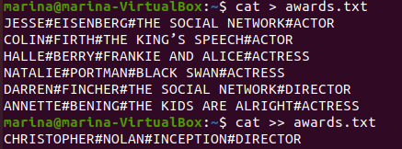

1. Create a file called “actors” in which you only include ACTORS.





1. Display the files which begin with a in your home directory.



1. Create a file called “directors” in which you only include DIRECTORS.





1. Display the lines of “awards” containing actresses. Show the line number.

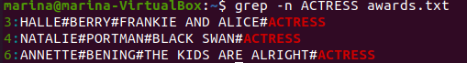

1. Display the lines in “awards” which are not directors. Show the line number.

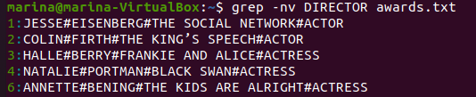

Part 2.

Create the file called “people.txt”

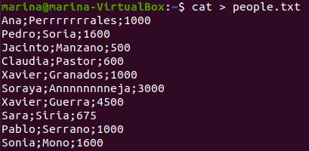

1. Create a file called “people2.txt”, containing those people whose name begins with J or S.

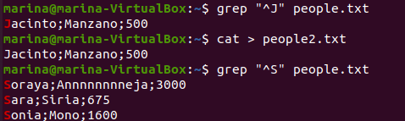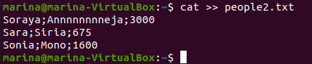

1. Create a file called “people3.txt”, containing those people whose names do not begin with S.

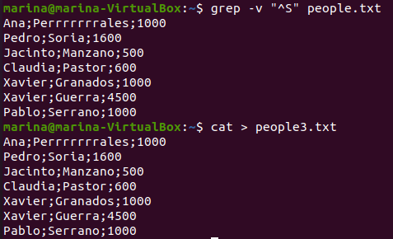

Also you can run it with:

grep -v "^S" people.txt > people3.txt

1. Display people whose name begin with S and redirect to file to “people_s.txt.

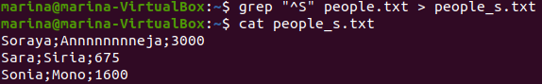

1. Display the number of people whose name begins with A (case insensitive).



1. Display how many people earn 1000 and concatenate the result in people2.txt





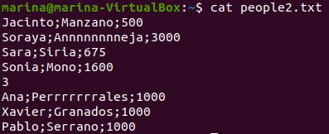

Part 3.

1. Create a file called list, including the contents from the current directory
2. Open the file to check if the content is right using cat, more and less and observe the differences

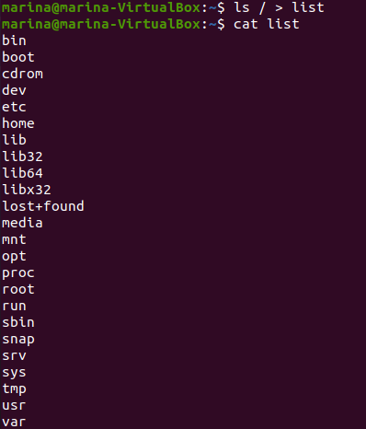

1. Print the contents of the current directory in reverse alphabetical order.

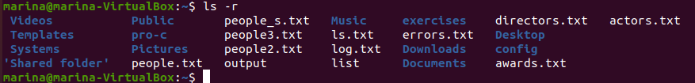

1. Create a file called inform, containing the long format list of the files and directories in your home directory.

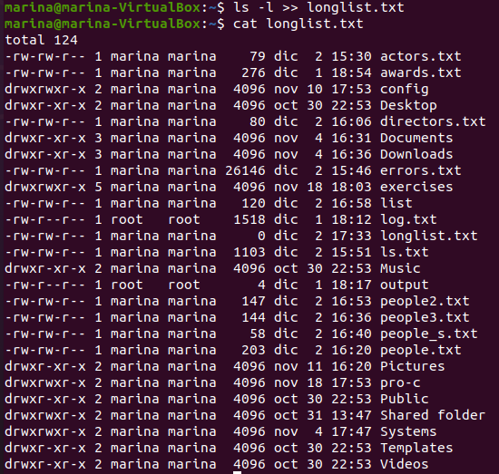

1. Find the word FILE in each file of your home directory, ignoring case and showing the line number (create files containing this word if you want any match).

